**Sports Activities**

**FOR 4-5 YEARS OLD CHILDREN**

**1.** **Simon Says**

**Description:** A leader gives commands starting with "Simon says," and children follow only if the command includes "Simon says."

**Materials:** None.

**Duration:** 10–15 minutes.

**Video:** [**https://www.youtube.com/watch?v=QRVTPFfOwcM**](https://www.youtube.com/watch?v=QRVTPFfOwcM)

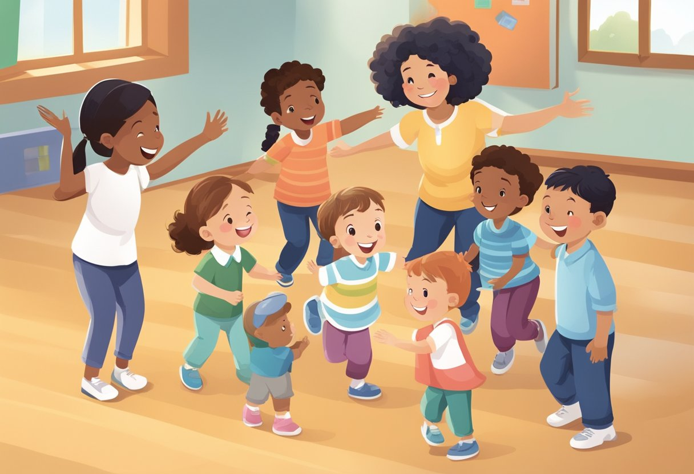

**2.** **Freeze Dance**

**Description**: Play music and let children dance freely; when the music stops, they must freeze in place.

**Materials**: Music player.

**Duration**: 15 minutes.

**Video:** [**https://www.youtube.com/watch?v=2UcZWXvgMZE**](https://www.youtube.com/watch?v=2UcZWXvgMZE)

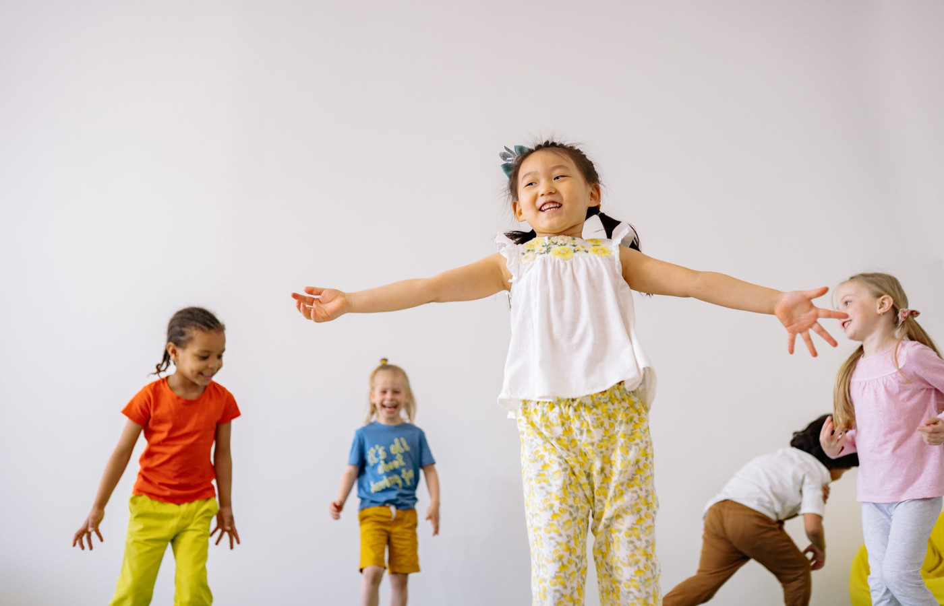

**3.** **Animal Walks**

**Description:** Kids mimic animal movements like hopping like a frog, waddling like a penguin, or crawling like a bear.

**Materials:** None.

**Duration:** 15–20 minutes.

**Video:** [**https://www.youtube.com/watch?v=-1-s8GBpFeQ**](https://www.youtube.com/watch?v=-1-s8GBpFeQ)

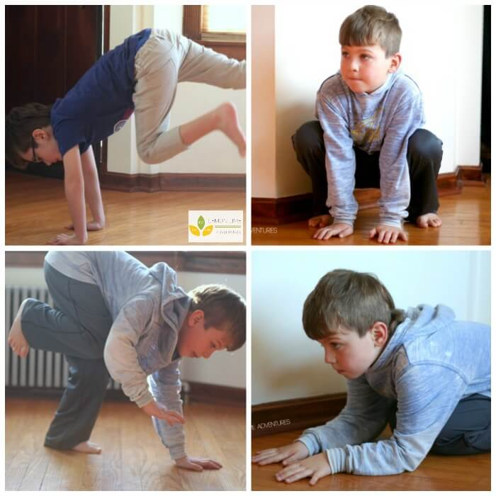

**4.** **Balloon Games**

**Description:** Inflate a balloon and carry out different games with kids such as have kids keep it in the air as long as possible by tapping it and many more.

**Materials:** Balloon.

**Duration:** 10–15 minutes.

**Video:** [**https://www.youtube.com/watch?v=trmb6LXGpA0**](https://www.youtube.com/watch?v=trmb6LXGpA0)

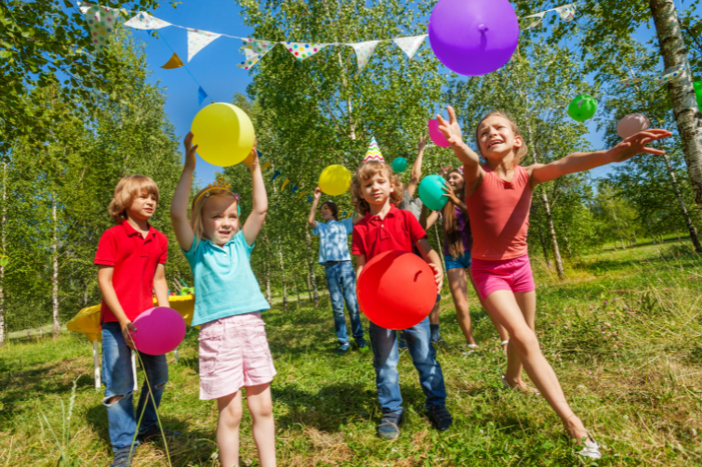

**5.** **Shadow Tag**

**Description:** A twist on traditional tag where kids step on each other's shadows to "tag."

**Materials:** None.

**Duration:** 15 minutes.

**Video:** [**https://www.youtube.com/watch?v=HKRAbxiBAn4**](https://www.youtube.com/watch?v=HKRAbxiBAn4)

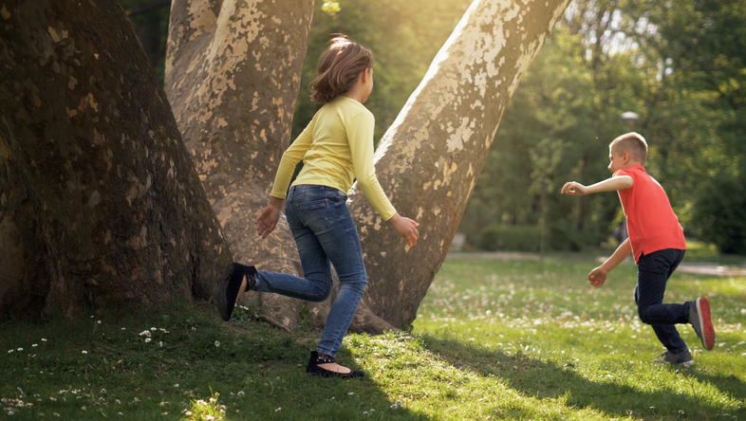

**6.** **Potato Sack Race**

**Description:** Kids hop from start to finish inside old sacks or pillowcases.

**Materials:** Sacks or pillowcases.

**Duration:** 15 minutes.

**Video:** [**https://www.youtube.com/watch?v=A7XYZ__HL6Q**](https://www.youtube.com/watch?v=A7XYZ__HL6Q)

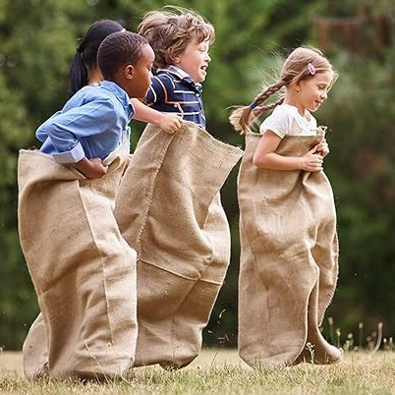

**7.** **Red Light, Green Light**

**Description: Children move forward on "green light" and stop on "red light," aiming to reach the leader first.**

**Materials: None.**

**Duration: 15 minutes.**

**Video:** [**https://www.youtube.com/watch?v=QuPLEv63liU**](https://www.youtube.com/watch?v=QuPLEv63liU)

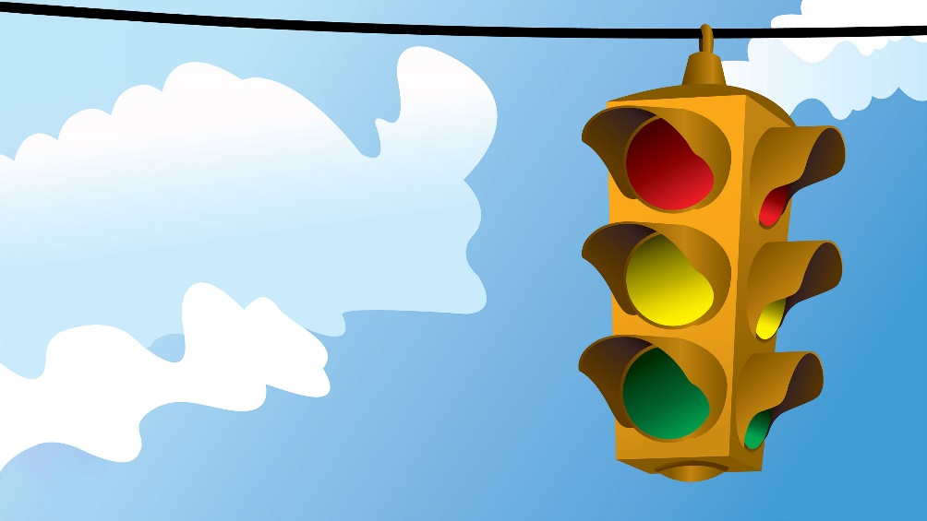

**8.** **Target Throw**

**Description:** Throw small balls or stones into a bucket or container from a distance.

**Materials:** Bucket, small balls or stones.

**Duration:** 20 minutes.

**Video:** [**https://www.youtube.com/watch?v=wsjJ-dkZSog**](https://www.youtube.com/watch?v=wsjJ-dkZSog)

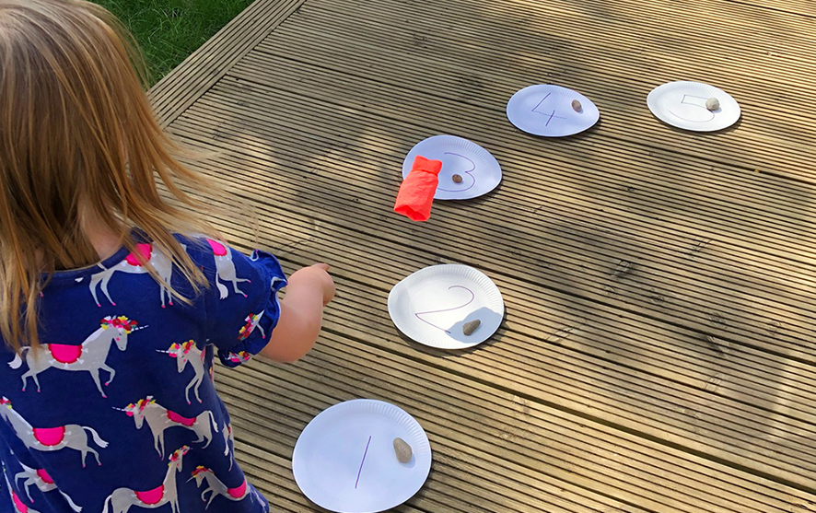

**9.** **Tug of War**

**Description:** Play a simple tug of war with a rope or towel, where both the parent and child pull on opposite sides.

**Materials:** Rope or towel.

**Duration:** 10 minutes.

**Video:** [**https://www.youtube.com/watch?v=QDkIdM1s8cg**](https://www.youtube.com/watch?v=QDkIdM1s8cg)

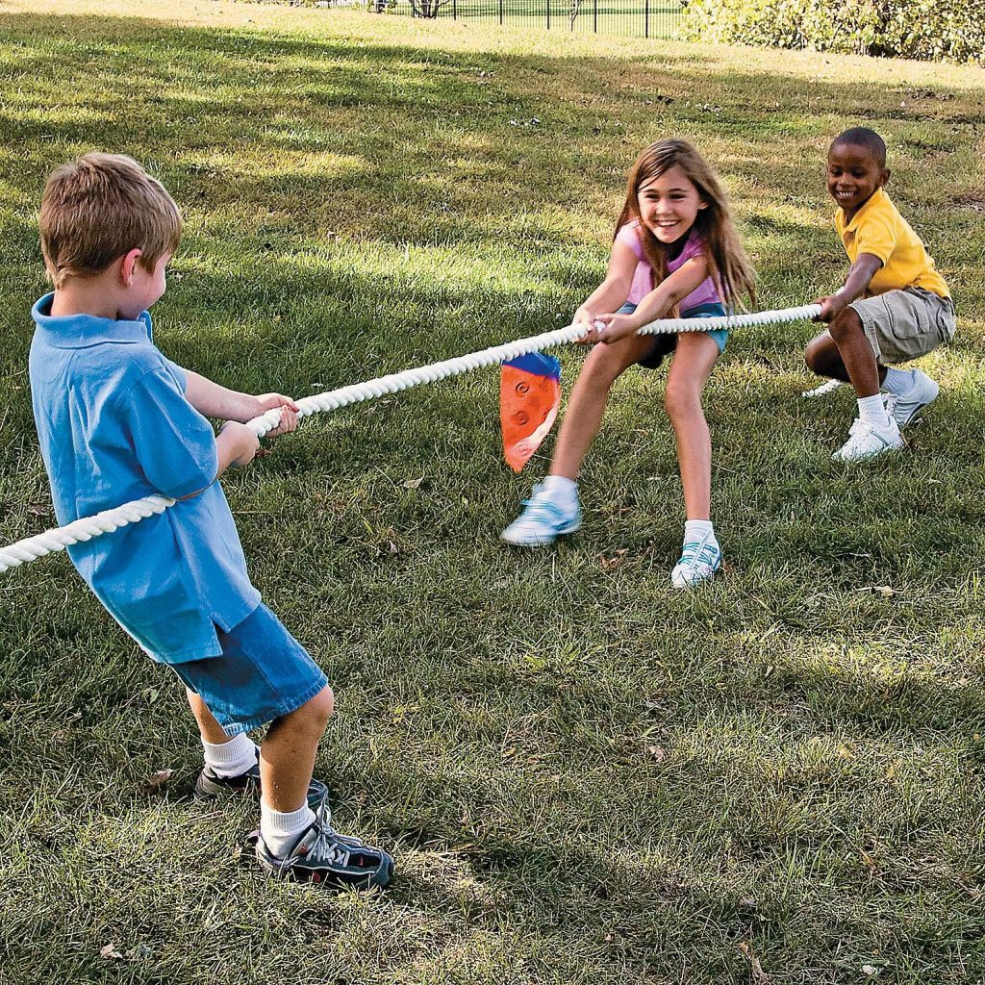

**10.** **Hopping Race**

**Description**: Have a hopping race where both the parent and child hop around the yard.

**Materials:** None.

**Duration:** 10 minutes.

**Video:** [**https://www.youtube.com/watch?v=vrzQ68rHLIs**](https://www.youtube.com/watch?v=vrzQ68rHLIs)

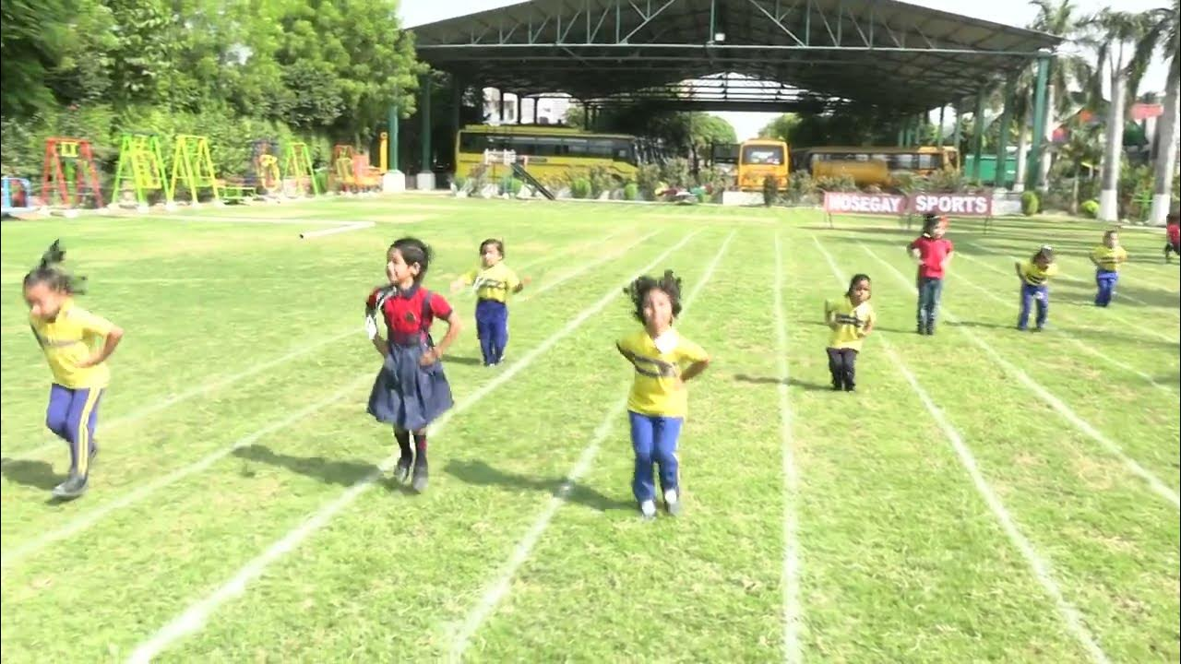

**11.** **Chase the Parent**

**Description:** The parent runs around, and the child tries to catch them. You can switch roles halfway through.

**Materials:** None.

**Duration:** 10 minutes.

**Video:** [**https://www.youtube.com/watch?v=qT5msWW3Wts**](https://www.youtube.com/watch?v=qT5msWW3Wts)

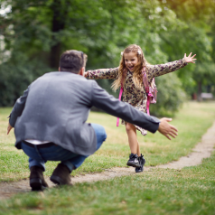

**12.** **Hopscotch**

**Description:** Draw a hopscotch grid on the floor and take turns hopping through it.

**Materials:** Chalk (for outdoors) or tape (for indoors).

**Duration:** 10 minutes.

**Video:** [**https://www.youtube.com/watch?v=qoeR5PXbz3Q**](https://www.youtube.com/watch?v=qoeR5PXbz3Q)

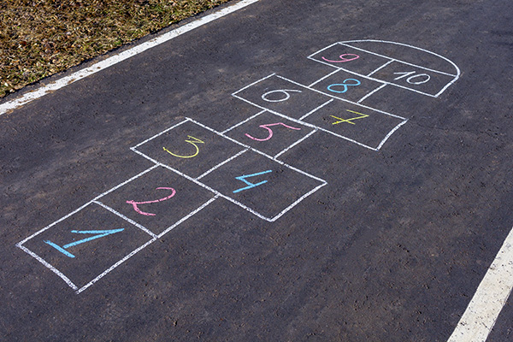

**13.** **Ring Toss**

**Description:** Toss rings onto a cone or bottle.

**Materials:** Plastic rings, cone/bottle.

**Duration:** 10 minutes.

**Video:** [**https://www.youtube.com/watch?v=9gj73TJsMeI**](https://www.youtube.com/watch?v=9gj73TJsMeI)

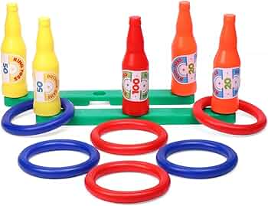

**14.** **Bubble Catching**

**Description: Blow bubbles and have the child try to catch them. Add a twist by timing them.**

**Materials: Bubble solution, bubble wand.**

**Duration: 10 minutes.**

**Video:** [**https://www.youtube.com/watch?v=pz-XOQohtgg**](https://www.youtube.com/watch?v=pz-XOQohtgg)

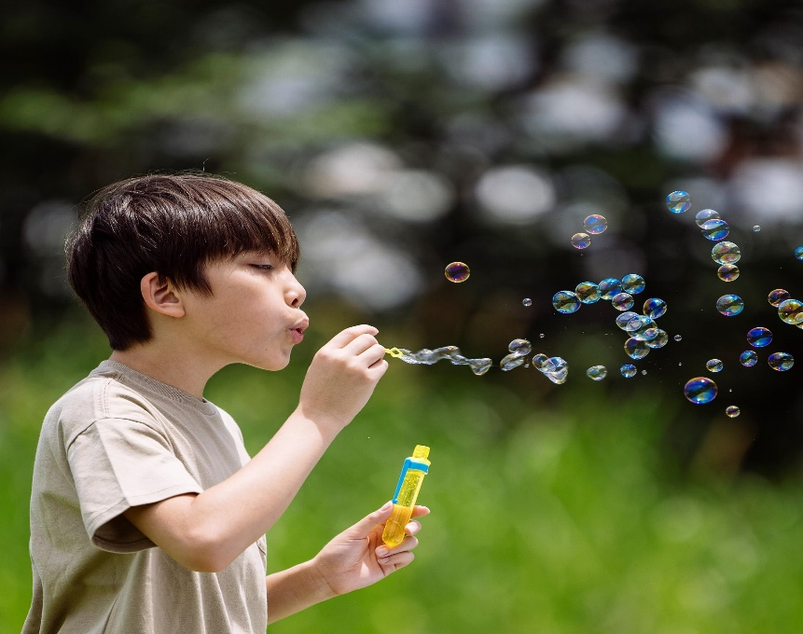

1. **Animal Sounds Bingo**

**Description**: Create a bingo card with pictures of animals and play their sounds (using a phone). Let your child match the sound to the animal.

**Materials**: Bingo cards (hand-drawn), phone/tablet for sounds.

**Duration**: 20 minutes.

<https://youtu.be/R5-tCRokCYs?si=0ikSBgAGVmQWfJ5i>

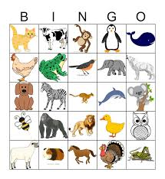

1. **Water Transfer Challenge**

**Description**: Provide cups and a sponge, and ask your child to transfer water from one container to another using the sponge.

**Materials**: Cups, sponge, water.

**Duration**: 10 minutes.

<https://youtu.be/k0V71nSuwrk?si=LSiOo9qNlSsoMekI>

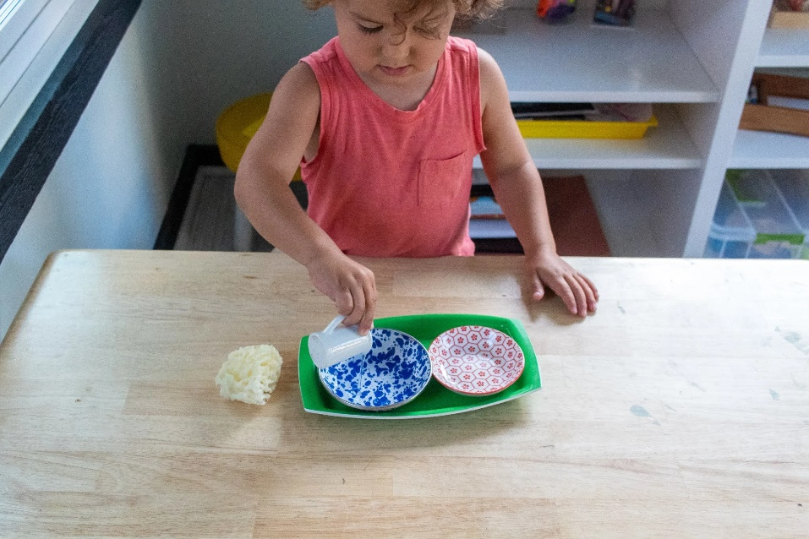

#### **Cup Stacking**

**Description**: Build towers or pyramids using plastic cups.

**Materials**: Plastic cups.

**Duration**: 15 minutes.

<https://youtu.be/SSpSFP0Os1I?si=xGEAqtXnLglrndhe>

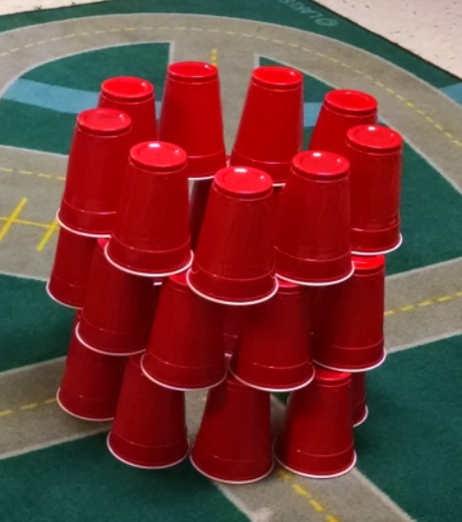

#### **Action Dice Game**

**Description**: Roll a dice to decide fun actions like jumping, clapping, etc.

**Materials**: Dice, action list.

**Duration**: 15 minutes.

<https://youtube.com/shorts/-iwMaLtYXoQ?si=f-h_SYrKkyWvDpq6>

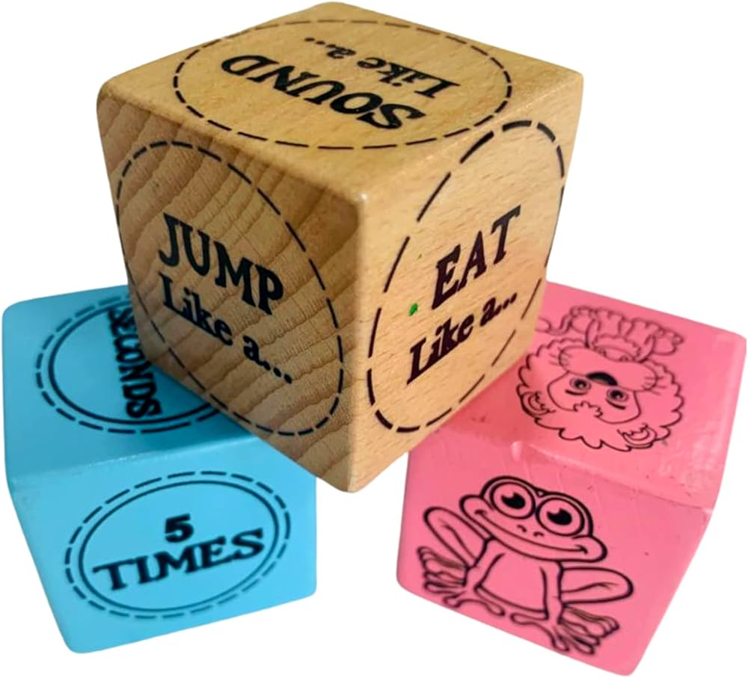

#### **Matching Shadow Shapes**

**Description**: Use a flashlight to cast shadows of objects, and match them to their shapes.

**Materials**: Objects, flashlight, paper.

**Duration**: 20 minutes.

<https://youtu.be/4417YmFFIVo?si=20BofzjU17GvIZqm>

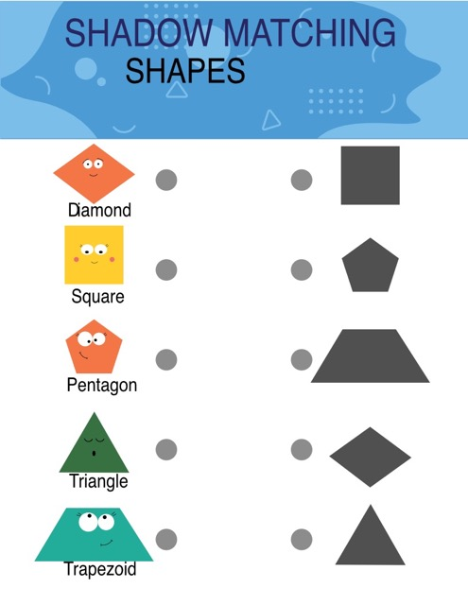

#### **Rainbow Scavenger Hunt**

**Description**: Ask your child to find objects matching the colors of the rainbow.

**Materials**: None.

**Duration**: 15 minutes.

<https://youtu.be/kZtTIt6ab5w?si=qQjSxHmZ83FDhoMk>

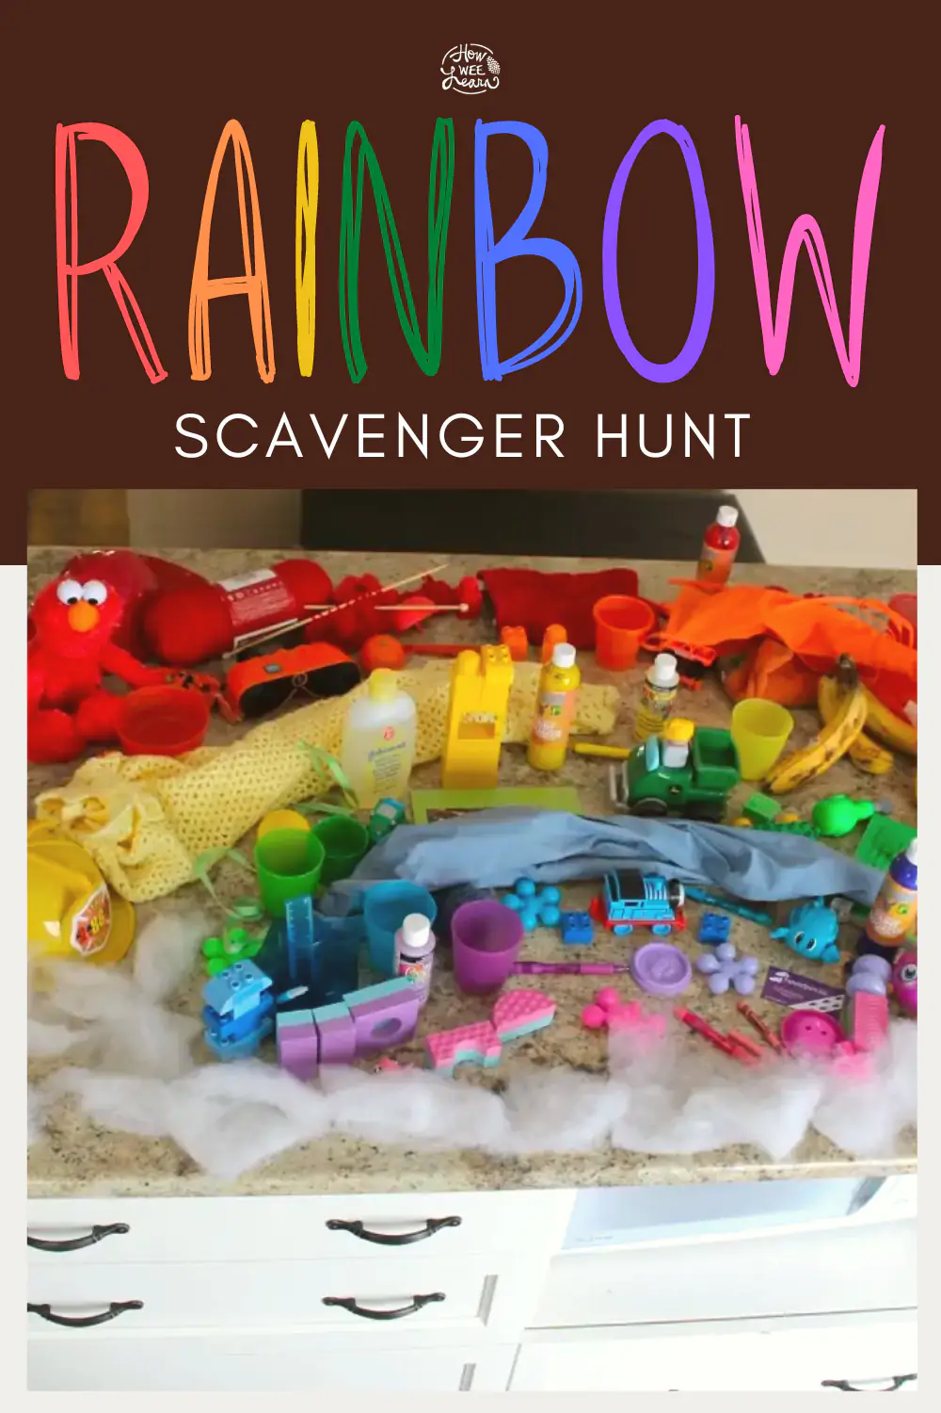

**FOR 6-8 YEARS OLD CHILDREN**

1. **Wheelbarrow Race**

**Description**: Parent holds the child’s legs while they walk on their hands, racing to the finish line.

**Materials**: None.

**Duration**: 10 minutes.

**Video**:<https://www.youtube.com/watch?v=txi_p2vuurk>

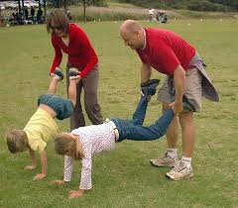

1. **Obstacle Course**

**Description:** Create an obstacle course using chairs, sticks, or cardboards for kids to crawl under or over.

**Materials:** Household items (e.g., chairs, pillows).

**Duration:** 20–25 minutes.

**Video:** [**https://www.youtube.com/watch?v=U00JMv0sWU0**](https://www.youtube.com/watch?v=U00JMv0sWU0)

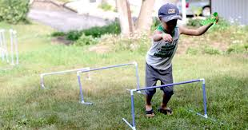

1. **Animal Relay**

**Description: Parent and child race, moving like different animals (e.g., hopping like a frog, waddling like a penguin).**

**Materials: None.**

**Duration: 10–15 minutes.**

**Video:** [**https://www.youtube.com/watch?v=-vX_rLoFpBE**](https://www.youtube.com/watch?v=-vX_rLoFpBE)

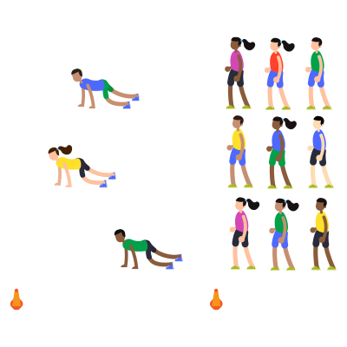

1. **Catch the Ball**

**Description: Toss a soft ball between the parent and child, gradually increasing the distance to make it more challenging.**

**Materials: Soft ball.**

**Duration: 10 minutes.**

**Video:** [**https://www.youtube.com/watch?v=IPe9fEZ8sSQ**](https://www.youtube.com/watch?v=IPe9fEZ8sSQ)

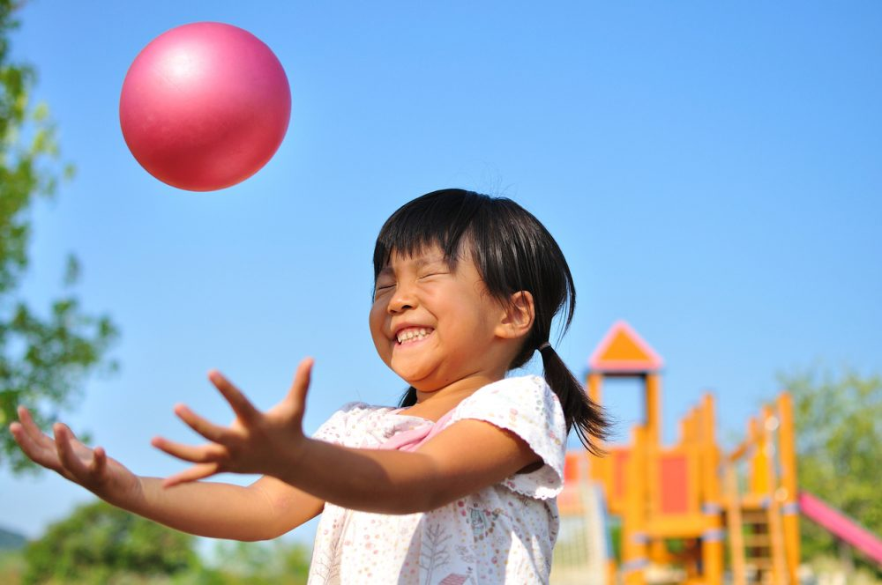

1. **Sock Toss**

**Description: Roll up socks into a ball and toss them into different targets (e.g., laundry basket).**

**Materials: Socks, basket.**

**Duration: 10 minutes.**

**Video:** [**https://www.youtube.com/watch?v=BWP3H_4J1LU**](https://www.youtube.com/watch?v=BWP3H_4J1LU)

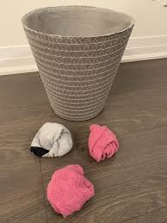

1. **Backwards Race**

**Description: Parent and child race walking backward. Whoever goes the furthest or fastest wins.**

**Materials: None.**

**Duration: 10 minutes.**

**Video:** [**https://www.youtube.com/watch?v=2mI68-XmsyQ**](https://www.youtube.com/watch?v=2mI68-XmsyQ)

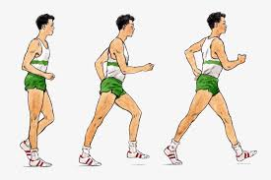

1. **Kick the Can**

**Description: Set a can or small object in the middle of the area, and challenge each other to kick it the furthest.**

**Materials: Can or small object.**

**Duration: 10 minutes.**

**Video:** [**https://www.youtube.com/watch?v=4TdcrkirZMM**](https://www.youtube.com/watch?v=4TdcrkirZMM)

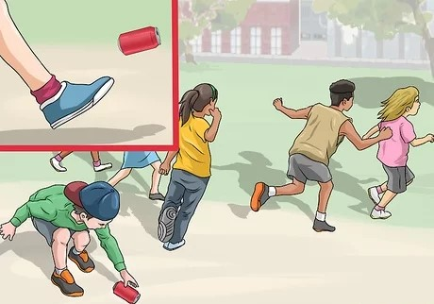

1. **Treasure Hunt**

**Description: Hide small items around the house and create clues for the child to find them.**

**Materials: Paper, pen, small items.**

**Duration: 20 minutes.**

[**https://youtu.be/30YvSojACMo?si=j4sf9h-zosrsBsfI**](https://youtu.be/30YvSojACMo?si=j4sf9h-zosrsBsfI)

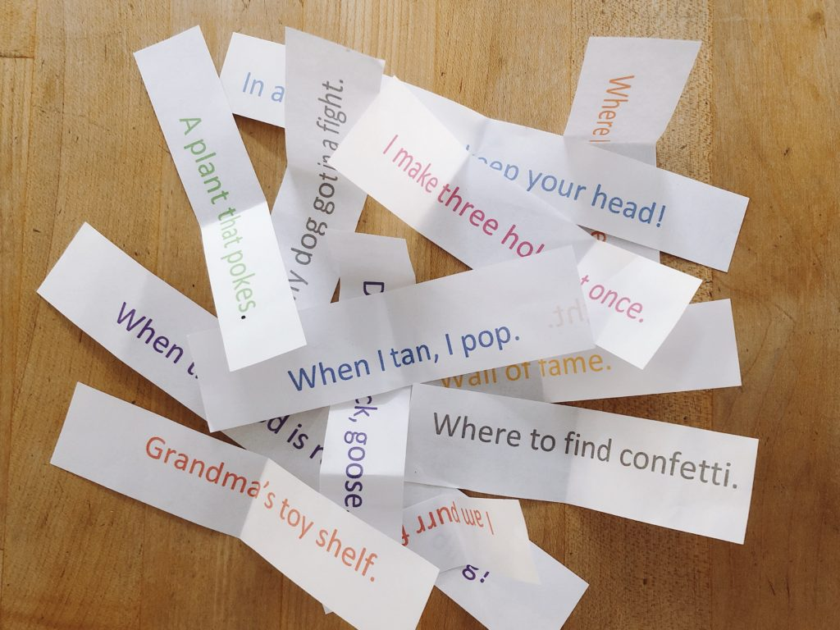

1. **Cardboard Maze**

**Description: Create a maze with cardboard and guide a marble through it.**

**Materials: Cardboard, glue, scissors, marble.**

**Duration: 30 minutes.**

[**https://youtu.be/rMSI1XQiDXY?si=gp85Pjkwm6vrCRbN**](https://youtu.be/rMSI1XQiDXY?si=gp85Pjkwm6vrCRbN)

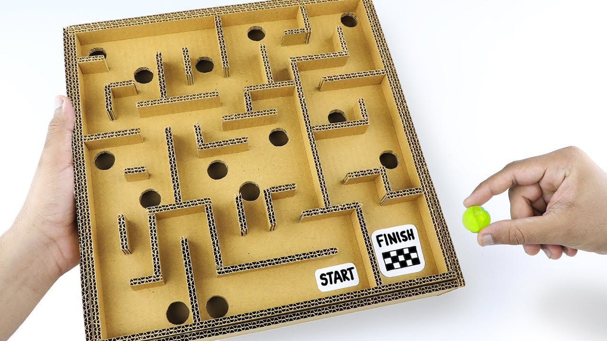

**10 Balloon Tennis**

**Description: Use balloons as tennis balls and rackets made from paper plates attached to sticks. Hit the balloon back and forth without letting it touch the ground.**

**Materials: Balloons, paper plates, tape, sticks.**

**Duration: 20 minutes.**

[**https://youtu.be/8fvMMRk75Uw?si=Jvnty_ztIwZhWKkl**](https://youtu.be/8fvMMRk75Uw?si=Jvnty_ztIwZhWKkl)

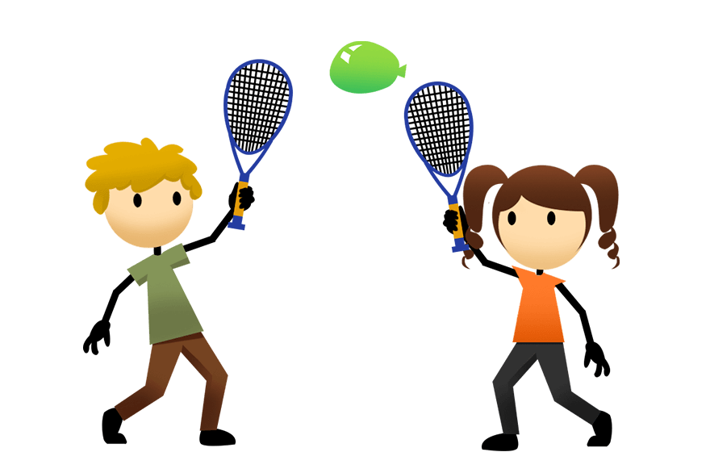

**11.Tape Jumping Lines**

**Description: Stick tape lines on the floor at increasing distances and challenge children to jump from one to the next.**

**Materials: Masking tape.**

**Duration: 20 minutes.**

[**https://youtu.be/juZrCaRH5-0?si=TSetjA6k_dvl1OkE**](https://youtu.be/juZrCaRH5-0?si=TSetjA6k_dvl1OkE)

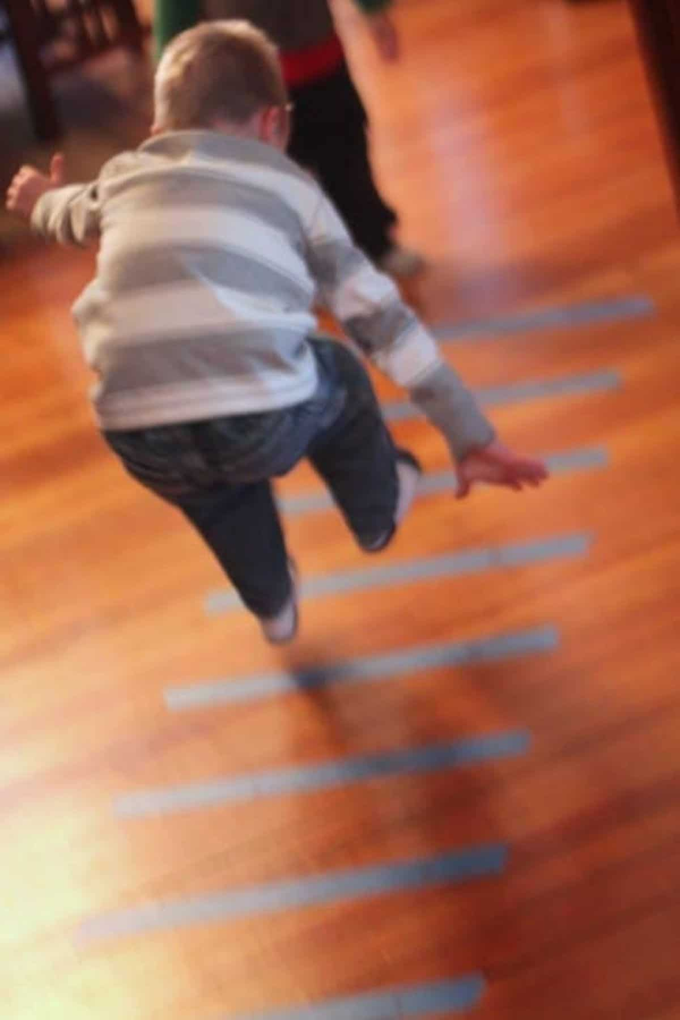

**12. Paper Plate Frisbee**

**Description: Make frisbees using paper plates and have children toss them at a target or to each other.**

**Materials: Paper plates.**

**Duration: 15 minutes**

[**https://youtu.be/tGNBhnbra7E?si=Qti0Q21-Mnk_bL1r**](https://youtu.be/tGNBhnbra7E?si=Qti0Q21-Mnk_bL1r)

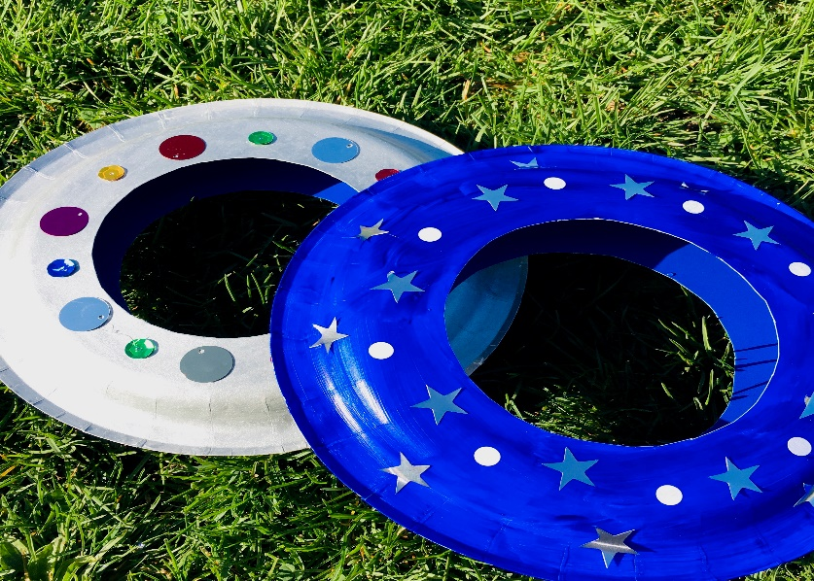

**13. Lemon-and-Spoon Race**

**Description: Balance a plastic egg (or ball) on a spoon and race across a room without dropping it.**

**Materials: Plastic egg or ball, spoon.**

**Duration: 15 minutes.**

[**https://youtu.be/XggZ6RXzjJc?si=JOGLrLVIiPqOTzjd**](https://youtu.be/XggZ6RXzjJc?si=JOGLrLVIiPqOTzjd)

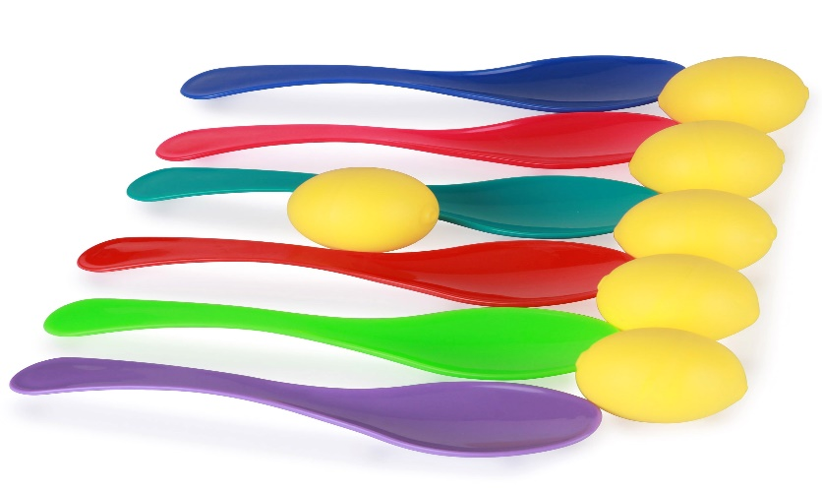

**14. Target Practice**

**Description: Set up targets (e.g., plastic cups) and throw small balls or bean bags to knock them over.**

**Materials: Plastic cups, small balls or bean bags.**

**Duration: 15 minutes.**

[**https://youtu.be/MLS3Bnp3gng?si=B9pgamav24vf5o9h**](https://youtu.be/MLS3Bnp3gng?si=B9pgamav24vf5o9h)

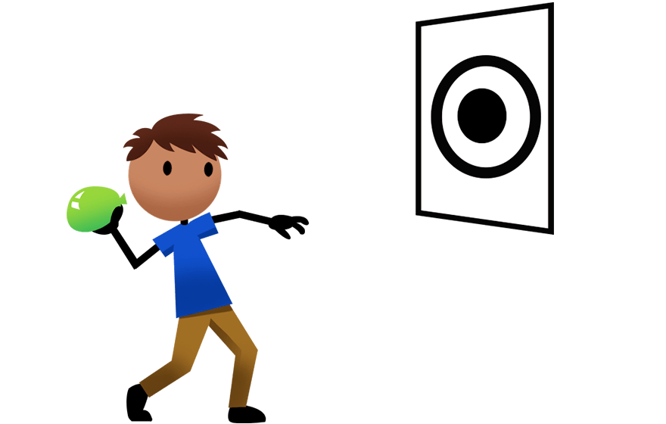

**15. Paper Airplane Throw**

**Description: Make paper airplanes and see whose can fly the farthest.**

**Materials: Paper.**

**Duration: 10 minutes.**

[**https://youtu.be/B-RUB-qNQ4g?si=mv4ag8dilozRGvOj**](https://youtu.be/B-RUB-qNQ4g?si=mv4ag8dilozRGvOj)

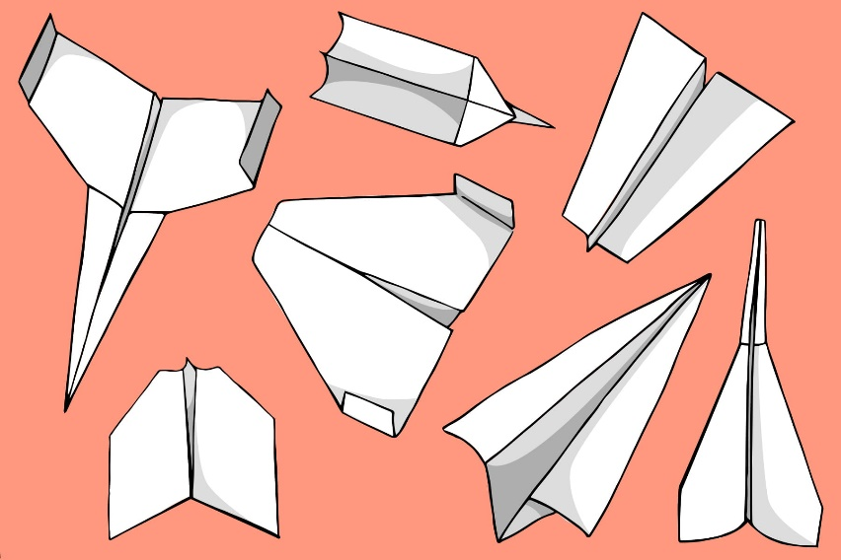

**16. Bean Bag Balance**

**Description: Balance a bean bag on your head and walk from one point to another.**

**Materials: Bean bags.**

**Duration: 10 minutes.**

[**https://youtu.be/BdRcUqbmENY?si=FV1IWoC4vWupvNN1**](https://youtu.be/BdRcUqbmENY?si=FV1IWoC4vWupvNN1)

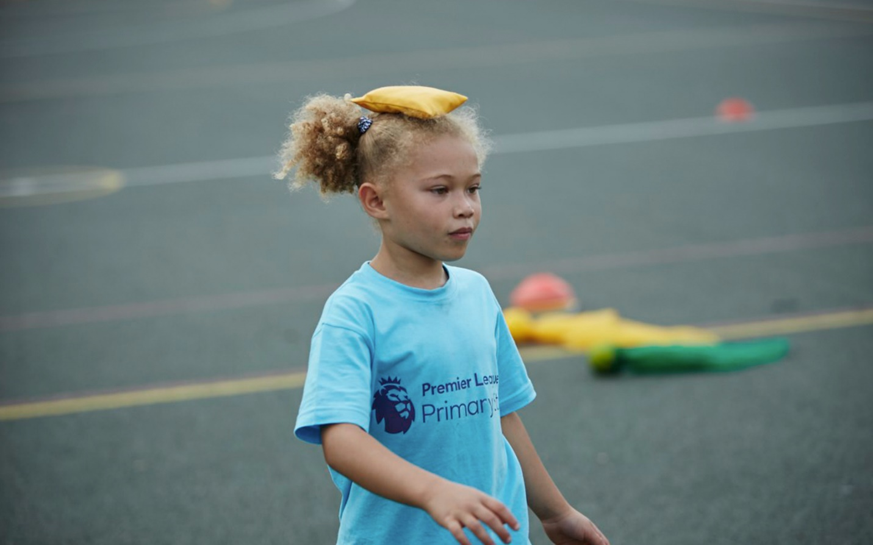

**17. Indoor Basketball**

**Description: Use a soft ball and a bucket to play basketball.**

**Materials: Bucket, soft ball.**

**Duration: 20 minutes.**

[**https://youtu.be/Ez3dw2h6vn8?si=SLgo_lcp5OAefYbx**](https://youtu.be/Ez3dw2h6vn8?si=SLgo_lcp5OAefYbx)

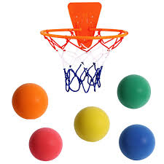

**18. Animal Walk Relay**

**Description: Take turns walking like different animals (e.g., crab, bear, frog) across the room.**

**Materials: None.**

**Duration: 20 minutes.**

[**https://youtu.be/-KezeE9-y0c?si=3pk12B-luEZt-RrF**](https://youtu.be/-KezeE9-y0c?si=3pk12B-luEZt-RrF)

